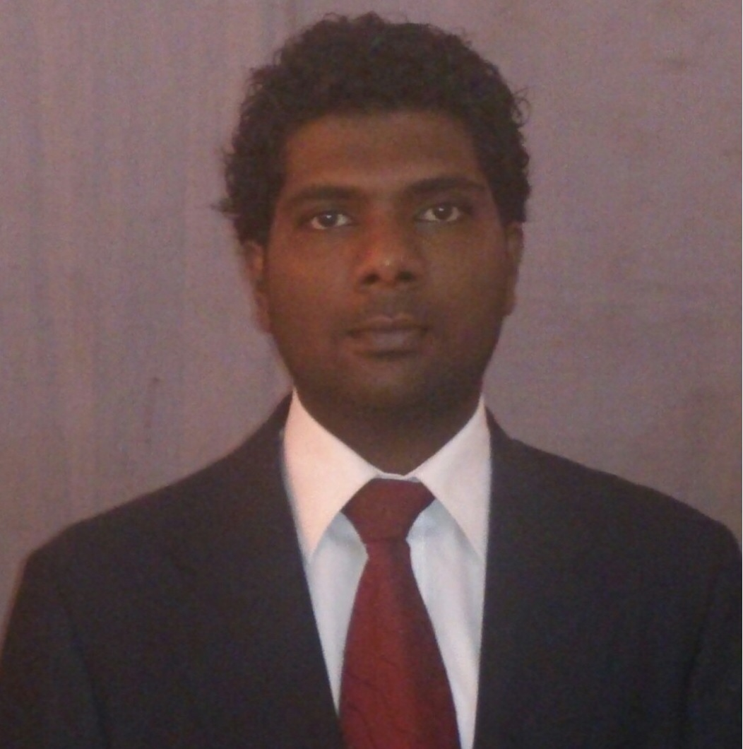

M. K. C. S. Sampath

Permanent Address  Mobile  Email | : 194, Meegahawatte, Delgoda.  : 0719013218  : sampathmulkirigala@gmail.com

Personal profile
I successfully combined my studies with work and other commitments showing myself to be self-motivated, organised and capable of working under pressure. I have a clear, logical mind with a practical approach to problem solving and a drive to see things through to completion. I enjoy working on my own initiative or in a team. In short, I am reliable, trustworthy, hardworking and eager to learn and have a genuine interest in PR.

Education
COLLEGE/UNIVERSITY | QUALIFICATION | GRADES
Faculty of Agriculture  University of Peradeniya | B.Sc. in Animal Science & Fisheries | Final GPA of 3.02 with  Sp. Hon’s Second class lower division pass
Ananda College, Colombo 10.  Wesley College, Colombo 09 | General Certificate of Examination, Advance Level in Science stream  General Certificate of Examination, Ordinary Level | Biology  Chemistry  Physics  Passed with 09 A’s and one B (A passes for Science, Mathematics and English) | B  C  C

Professionals Qualifications
INSTITUTE/ORGANIZATION | QUALIFICATIONS | AWARDS
Biotechnology Centre, Faculty of Agriculture, University of Peradeniya  National Aquaculture Development Authority (NAQDA)  National Livestock Development Board (NLDB)  Nelna Own Farm Eheliyagoda | Certificate Course in Basic Techniques in Molecular Biology  03 Day Training Programme on Ornamental Fish Breeding  Implant Training  Implant Training | Completed  Completed  Completed  Completed

Working Experiences
- Working as a Quality Assurance Executive at JP Poultry Products (Pvt) Ltd, Walowitawatte, Badalgama from July, 2014.

Extra-curricular activities
- President of the “Society of Animal Science” at Faculty of Agriculture at University of Peradeniya
- A committee member of “Society of Aquaculture Resources Conservation” at Faculty of Agriculture at University of Peradeniya
- A committee member of “Art Circle” at Faculty of Agriculture at University of Peradeniya
- A member of school junior prefect board at Ananda College from 2003 to 2004
- A member of school Art Circle and Sinhala Ochestra

Research and Publications
Establishing a model for heat stress studies using Wistar rats (Rattus norvegicus) and mice (Mus musculus)
Published on “Proceedings” at 23rd Annual Student Research Session (Editors- Dr. Janak. K. Vidanarachchi and Dr. S. M. C. Himali) and won the 3rd place for best poster presentation.

Personal details
Name with Initials | : M. K. C. S. Sampath
Date of Birth | : 13 March, 1987
Age | : 26 years
National Identity Card Number | : 870730594 V
Gender | : Male
Religion | : Buddhist
Nationality | : Sri Lankan
Marital Status | : Single

Recommendations
Prof. H.W. Cyril  Head of the Department  Department of Animal Science  Faculty of Agriculture  University of Peradeniya |  | Dr. Barana. C. Jayawardhene  Senior Lecturer  Department of Animal Science  Faculty of Agriculture  University of Peradeniya
Email | : hwcyril@pdn.ac.lk | Email | : baranaj@pdn.ac.lk
Telephone | : + 94 81-239 5318 | Telephone | : +94-81-2395317

I hereby certify that the above mentioned details are true and correct according to my knowledge.

